We are proud to introduce Optomap®to our practice, the latest in retinal imaging! This painless scan takes a digital image of the back of the eye and is recommended for every patient, every year as part of your annual exam. This instrument assists the doctor in identifying more ocular damage and/or disease, such as macular degeneration, retinal holes, tears or detachments, as well as systemic conditions like high blood pressure, high cholesterol, diabetes and even types of cancer. It is a co-pay of only $34 and the great news is you will not have to be dilated today!
To be able to detect and diagnose most ocular damage and disease without the
Optomap, you would have to be dilated!
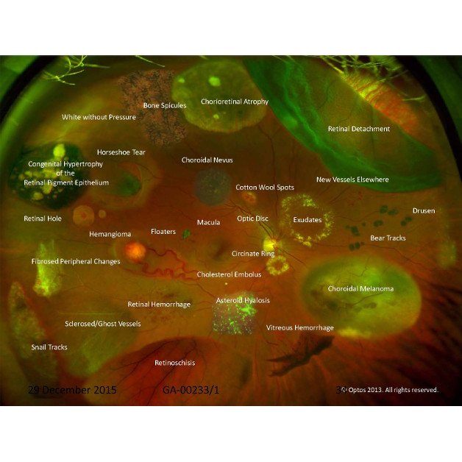
*IF YOU WOULD LIKE TO DECLINE THIS SERVICE, PLEASE SEE THE FRONT DESK

